RIVN Rivian Automotive, Inc. under CEO Robert Scaringe (after new 4.6 Billion package)

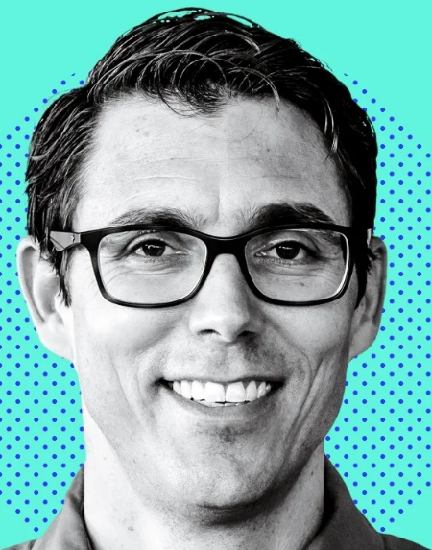

6 | The Top |  | H | H | T |  | 3 | 3 | 2 |  | 8
5 | The Fifth Place |  | H | T | T |  | 3 | 2 | 2 |  | 7
4 | The Fourth Place |  | H | T | T |  | 3 | 2 | 2 |  | 7
3 | The Third Place |  | T | T | T |  | 2 | 2 | 2 |  | 6
2 | The Second Place |  | H | H | H |  | 3 | 3 | 3 |  | 9
1 | The Beginning |  | T | T | T |  | 2 | 2 | 2 |  | 6

Click below to view the interpretations and cases:

https://icic.com/?p=8984

HEXAGRAM 47 - K'un - Oppression (Exhaustion)

Above TUI THE JOYOUS, LAKE
Below K'AN THE ABYSMAL, WATER

- The lake is above, water below; the lake is empty, dried up. (1)
Exhaustion is expressed in yet another way:
- at the top, a dark line is holding down two light lines;
below, a light line is hemmed in between two dark ones.
- The upper trigram belongs to the principle of darkness,
the lower to the principle of light.
Thus everywhere superior men are oppressed and held in restraint by inferior men.

THE JUDGMENT

OPPRESSION.
Success.
Perseverance.
The great man brings about good fortune.
No blame.
When one has something to say,
It is not believed.

- Times of adversity are the reverse of times of success, but
- they can lead to success if they befall the right man.
When a strong man meets with adversity,
- he remains cheerful despite all danger, and
- this cheerfulness is the source of later successes;
it is that stability which is stronger than fate.
- He who lets his spirit be broken by exhaustion certainly
  - has no success.
- But if adversity only bends a man,
  - it creates in him a power to react that is bound in time to manifest itself.
No inferior man is capable of this.
Only the great man
- brings about good fortune and
- remains blameless.
It is true that for the time being outward influence is denied him,
because his words have no effect.
Therefore in times of adversity
it is important to be
- strong within and
- sparing of words.

THE IMAGE

There is no water in the lake:
Thus the superior man stakes his life
On following his will.

When the water has flowed out below,
the lake must
- dry up and
- become exhausted.
That is fate.
This symbolizes an adverse fate in human life.
In such times there is nothing a man can do but
- acquiesce in his fate and
- remain true to himself.
This concerns the deepest stratum of his being,
for this alone is superior to all external fate.

THE LINES

Six at the beginning means:
One
- sits oppressed under a bare tree And
- strays into a gloomy valley.
For three years one sees nothing.

When adversity befalls a man,
it is important above all things for him
- to be strong and
- to overcome the trouble inwardly.
If he is weak, the trouble overwhelms him.
Instead of proceeding on his way,
he
- remains sitting under a bare tree and
- falls ever more deeply into gloom and melancholy.
This makes the situation only more and more hopeless.
Such an attitude comes from an inner delusion that
he must by all means overcome.

Nine in the second place means:
One is oppressed while at meat and drink.
The man with the scarlet knee bands is just coming.
It furthers one to offer sacrifice.
To set forth brings misfortune.
No blame.

This pictures a state of inner oppression.
Externally, all is well,
one has meat and drink.
But
one
- is exhausted by the commonplaces of life, and
- there seems to be no way of escape.
Then help comes from a high place.
A prince - in ancient China princes wore scarlet knee bands - is in search of able helpers.
But there are still obstructions to be overcome.
Therefore it is important to meet these obstructions in the invisible realm by
- offerings and
- prayer.
To set forth without being prepared would be disastrous,
though not morally wrong.
Here a disagreeable situation must be overcome by patience of spirit.

Six in the third place means:
A man
- permits himself to be oppressed by stone, And
- leans on thorns and thistles.
He
- enters his house and
- does not see his wife.
Misfortune.

This shows a man who is restless and indecisive in times of adversity.
- At first he wants to push ahead,
- then he encounters obstructions that, it is true,
mean oppression only when recklessly dealt with.
He
- butts his head against a wall and in consequence
- feels himself oppressed by the wall.
Then he leans on things
- that have in themselves no stability and
- that are merely a hazard for him who leans on them.
Thereupon
he
- turns back irresolutely and
- retires into his house,
only to find, as a fresh disappointment,
that his wife is not there.

Confucius says about this line:
- If a man permits himself to be oppressed by something that ought not to oppress him,
  - his name will certainly be disgraced.
- If he leans on things upon which one cannot lean,
  - his life will certainly be endangered.
- For him who is in disgrace and danger, the hour of death draws near;
  - how can he then still see his wife?

MOVING HEXAGRAM

Click below to view the interpretations and cases:

https://icic.com/?p=8990

HEXAGRAM 49 – Ko – Revolution (Molting)

Above TUI THE JOYOUS, LAKE
Below LI THE CLINGING, FIRE

The Chinese character for this hexagram means in its original sense
an animal's pelt, which is changed in the course of the year by molting.
From this the word is carried over to apply to
- the "molting" in political life,
- the great revolutions connected with changes of governments.
The two trigram making up the hexagram are
the same two that appear in K'uei, OPPOSITION (38), that is,
the two younger daughters, Li and Tui.
But while
there
- the elder of the two daughters is above, and
  - what results is essentially only an opposition of tendencies,
here
- the younger daughter is above.
  - The influences are in actual conflict, and
  - the forces combat each other like fire and water (lake), each trying to destroy the other.
Hence the idea of revolution.

THE JUDGMENT

REVOLUTION
On your own day
You are believed.
Supreme success,
Furthering through perseverance.
Remorse disappears.

Political revolutions are extremely grave matters.
They should be undertaken
- only under stress of direst necessity,
- when there is no way out.

- Not everyone is called to this task,
- but only the man who has the confidence of the people, and
even he only when the time is ripe.
- He must then proceed in the right way, so that
- he
  - gladdens the people and, by enlightening them,
  - prevents excesses.
Furthermore,
he
- must be quite free of selfish aims and
- must really relieve the need of the people.
Only then does he have nothing to regret.

Times change, and with them their demands.
- Thus the seasons change in the course of the year.
In the world cycle also
- there are spring and autumn in the life of peoples and nations, and
- these call for social transformations.

THE IMAGE

Fire in the lake: the image of REVOLUTION.
Thus the superior man
- Sets the calendar in order And
- makes the seasons clear.

Fire below and the lake above combat and destroy each other.
So too in the course of the year a combat takes place between
- the forces of light and
- the forces of darkness,
  - eventuating in the revolution of the seasons.
Man masters these changes in nature by
- noting their regularity and
- marking off the passage of time accordingly.
In this way
- order and clarity appear in the apparently chaotic changes of the seasons, and
- man is able to adjust himself in advance to the demands of the different times.

